

**Seminar Report**

**On**

**Skin Lesion Classification using Deep Learning**

**By**

**Vasu Kalariya**

**PRN : 1032180772**

**Roll : PE29**

**Under the guidance of**

**Dr. Pradnya Siddhivinayak Kulkarni**

**MIT-World Peace University (MIT-WPU)**

**Faculty of Engineering**

**School of Computer Engineering & Technology**

**\* 2020-2021 \***



**MIT-World Peace University (MIT-WPU)**

**Faculty of Engineering**

**School of Computer Engineering & Technology**

**CERTIFICATE**

This is to certify that Mr. Vasu Kalariya of B.Tech., School of Computer Engineering & Technology, Trimester – IX, PRN. No. 1032180772, has successfully completed seminar on

**Skin Lesion Classification using Deep Learning**

To my satisfaction and submitted the same during the academic year 2020-2021 towards the partial fulfillment of degree of Bachelor of Technology in School of Computer Engineering & Technology under Dr. Vishwanath Karad MIT-World Peace University, Pune.

Prof._________________ Prof. Dr. M. V. Bedekar

Seminar Guide Head

School of Computer Engineering & Technology

**LIST OF FIGURES**

**Sr. No. Figure Page No.**

1 Types of Skin Lesions 9

2 DNN 14

3 VGG-19 16

4 Modified VGG-19 17

5 Accuracy comparison with and without DNN 18

6 Confusion Matrix 19

7 Lesion Type Vs. Age Boxplot 20

**LIST OF TABLES**

**Sr. No. Table Page No.**

1 Literature review table 11

2 CLASSIFICATION REPORT TABLE FOR MODIFIED VGG-19 17

**ABBREVIATION**

* CNN : Convolution Neural Network
* NMSC : Non-melanoma Skin Cancer
* MSC : Melanoma Skin Cancer
* KNN : K nearest neighbor
* ReLU : Rectified Linear Unit
* DNN : Deep Neural Network
* DCNN : Deep Convolution Neural Network
* VGG : Visual Geometry Group

**ACKNOWLEDGEMENT**

# I, Vasu Kalariya, roll no.: PE-29, would like to express my gratitude to Dr. Pradnya Kulkarni ma’am for being my seminar guide and helping me out with my topic. My topic was a challenging one, but Dr. Pradnya Kulkarni ma’am gave her valuable insights so that I am not stuck anywhere.

# I cannot express enough thanks to my family and friends for supporting me and giving me valuable suggestions.

**INDEX**

Sr. No Topic Page No

1 TECHNICAL CONTENT 8-20

1.1 Introduction 8

1.2 Structure of the report 9

2. Literature Survey 10

2.1 Methodology followed in previous studies 10

3. Details of design/technology 15-23

3.1 CONVOLUTIONAL NEURAL NETWORK 15

3.2 TRANSFER LEARNING 16

3.3 DENSENET-121 17

3.4 RESNET-50 and WIDE RESNET-101 17

3.5 VGG-19 18

4. CONCLUSION 23

5. REFERENCES 24

6. BASE PAPER FIRST PAGE 25

7. PLAGIARISM CHECK REPORT 26

# **ABSTRACT**

# Skin Cancer is the most well-known (representing 40% of malignancy cases all around the world) and conceivably hazardous kind of diseases. It was analyzed in about 5.6 million people a year ago. Mechanized order of skin injuries through pictures has been a test over time in light of fine fluctuation in their appearance. Deep Learning methods display potential in handling fine-margined picture-based investigation and figure out how to give exact outcomes. There are 7 different types of skin cancer namely actinic keratoses, basal cell carcinoma, benign keratosis-like lesions, dermatofibroma, melanoma, melanocytic nevi and vascular lesions. With this we can easily detect and classify it.

# **KEYWORDS**

# Deep Learning, Convolutional Neural Network, Lesion, PyTorch, Transfer Learning.

**1. TECHNICAL CONTENT**

**1.2 Introduction**

Human pores and skin is immensely complicated in nature. It is split into predominant membranes, the Epidermis and the Dermis. Epidermis is the outermost layer which serves as a protecting shield, preserving fluids withinside the frame and blocking bacteria. Dermis includes connective tissues, presenting the pores and skin with tensile electricity and elasticity. Skin is subjected to dust, pollution, microbes and UV radiations. Exposure to those has a tendency to be the number one motive because humans turn out to be contracting pores and skin sicknesses like Skin Cancer. Skin Cancer is the bizarre boom of cells withinside the epidermis or dermis that has the cap potential to unfold to sure components of the human frame. Heavy publicity to ultraviolet radiation, susceptible immune device in sure people and mild pores and skin color usually make contributions to the upward push in instances of pores and skin cancer. It influences 2.5 million humans yearly in international locations consisting of Australia, New Zealand, South Africa and the US.

Skin lesions, as proven underneath in Figure 1, are extensively categorized into Malignant (cancerous kind) and Benign (non-cancerous kind). Though benign pores and skin lesions are commonly harmless, a number of its bureaucracy are pre-cancerous situations and want treatment. Benign Skin lesions are in particular categorized into actinic keratoses, benign keratosis-like lesions, dermatofibroma, melanocytic nevi and vascular lesions. Malignant kind pores and skin lesions want extensive care and are doubtlessly lethal. Malignant pores and skin lesions are in addition categorized into Non-cancer Skin Cancer (NMSC) and Melanoma Skin Cancer (MSC). NMSC is classed into Basal Cell Carcinoma and Squamous Cell Carcinoma [8]. Any form of most cancers goals the regular functioning of the immune machine and alters it. Hence, it will become paramount to diagnose cancers as quickly as feasible and get right treatment.

# Statistical facts from all around the global suggests that pores and skin most cancers, if detected early, is curable, however frequently is diagnosed very late. At this factor of time, conventional remedies are useless and the most cancers cells mutate and unfold to the alternative inner elements of the body. Primary prognosis is carried out visually, accompanied via way of means of scientific screening, dermoscopic analysis, biopsy and histopathological examination. Despite enormous improvements in pores and skin most cancers treatment, early and correct prognosis price stands at a median of 65% (challenge to enjoy of the specialist). That is in which superior and smart deep studying strategies come to assist. Deep Learning as a area appears promising with regards to image-primarily based totally detection and analysis [3]. In contemporary-day times, deep studying is helping scientific practitioners and researchers to find out hidden facts possibilities thereby presenting docs with goal assessment of each situation and assist them deal with it better, contributing to life-saving scientific decisions.

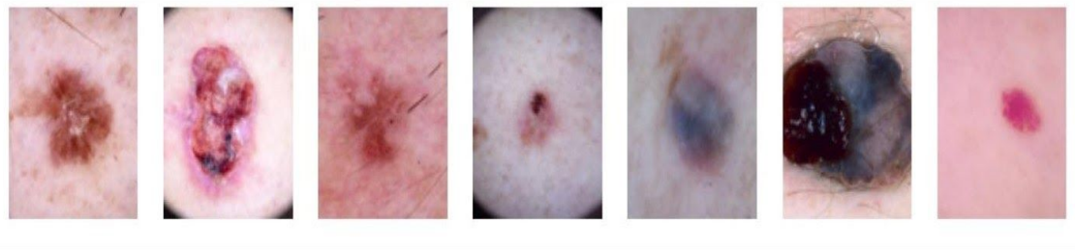

**FIGURE 1**: Types of Skin Lesions: Actinic Keratoses, Basal Cell Carcinoma, Benign Keratosis-like lesions, Dermatofibroma, Melanocytic Nevi, Melanoma and Vascular Lesions going from left to right

**1.2 Structure of the report**

# The structure of the remaining report is as follows: Section 2 will cover the literature survey done with respect to the concerned topic. Section 3 will focus on the details of design/technology. Discussion on the report’s findings and future scope in this area is discussed in the conclusion section.

# **2. Literature Survey**

# **2.1 Methodology followed in previous studies**

# Considerable quantity of official studies has been carried out in picture processing and it's far being utilized in scientific sciences day in and time out the usage of one of a kind device mastering and deep mastering techniques. Clinicians and medical doctors are information the positives of the usage of slicing part generation in each a part of their treatment. Following studies works have ordinarily stimulated the approach provided on this paper.

Andre Esteva et al. categorised pores and skin lesion photographs into 23 awesome training the usage of GoogleNetInception v3 network. The accuracy completed with this technique turned into 72.1%. 129,450 scientific photographs have been used which consisted of 2032 diseases. t-SNE set of rules turned into implemented for dimensionality reduction. Haseeb Younis et al. hired MobileNet and CNN which includes 93 layers out of which five layers have been dropped and the final 88 have been taken into consideration to expand a pores and skin lesion class machine. The weights of all layers besides the closing 25 have been freezed and have been used for training. Using the HAM10000 Dataset an accuracy of 97.1 % turned into completed with a 70-30 educate check cut up withinside the dataset. V. Pomponiu et al. used the ISBI 2016 Challenge dataset for Skin Lesion Analysis 399 to categorise three nine RGB photographs augmented to ten thousand photographs into 2 training namely, benign nevi and MM. A pretrained CNN turned into carried out with the useful resource of Caffe deep mastering library. The capabilities extracted from the closing three layers of the CNN have been fed to a custom classifier constructed the usage of K nearest neighbor (kNN with 10-fold cross validation to estimate generalization error and k=2). Maximum accuracy of 93.64±1.9 ​turned into completed. Adria Romero Lopez et al. extensively utilized the identical dataset, and hired switch mastering with the pretrained VGG-16 Network. During quality tuning of the ConvNet network, most effective the better stage part of the convolutional layers has been trained, preserving the decrease stage layers freezed. The RMSProp Optimizer characteristic turned into used for binary class of photographs into malignant or benign. The machine completed an accuracy of 81.33%, sensitivity of 78.66% and precision of 79.74%

**Table 1. Literature review table**

|  |  |  |  |  |
| --- | --- | --- | --- | --- |
| **Title of the paper​** | **Year of**  **publication​** | **Methods used​** | **Accuracy​** | **Research Gap​** |
| Skin lesion classification using GAN based data augmentation | 2019 (IEEE) | Generative Adversarial Networks (GANs) | 86% | The classifier performance can be improved with more images |
| SKIN LESION CLASSIFICATION USING HYBRID DEEP NEURAL NETWORKS | 2019 (IEEE) | Convolutional Neural Networks (CNNs) | 90.69 % | Extending the model to incorporate more advanced pretrained models such as DenseNets could improve classification performance |
| Skin Lesion Classification using Deep Learning and Image Processing | 2021 (IEEE) | Convolutional Neural Networks (CNNs), Transfer learning | 99% | Novelness is minimised as the authors have relied more on the transfer learning approach and used pretrained architectures. |

|  |  |  |  |  |
| --- | --- | --- | --- | --- |
| **Title of the paper​** | **Year of**  **publication​** | **Methods used​** | **Accuracy​** | **Research Gap​** |
| Attention Residual Learning for Skin Lesion Classification | 2019 (IEEE) | Attention Residual Learning | 91.7% | Lesions are classified only into two types cancerous and non-cancerous |
| FCN Based DenseNet Framework for Automated Detection and Classification of Skin Lesions in Dermoscopy Images | 2020 (IEEE) | Fully Convolution Network (FCN) | 98% | The encoderdecoder network has less accuracy compared to integrated with the CRF model |
| DEEP LEARNING FOR SKIN CANCER DIAGNOSIS WITH HIERARCHICAL ARCHITECTURES | 2019 (IEEE) | HIERARCHICAL CNN | 87.6% | Validation of results on a larger dataset that comprises more classes of non-melanocytic lesions is required. |

|  |  |  |  |  |
| --- | --- | --- | --- | --- |
| **Title of the paper​** | **Year of**  **publication​** | **Methods used​** | **Accuracy​** | **Research Gap​** |
| Skin lesion classification with ensembles of deep convolutional neural networks | 2018 (IEEE) | deep convolutional neural networks | 89.1% | The proposed CNN framework need extension using additional CNN networks and customization for actual usage |
| The Development of a Skin Cancer Classification System for Pigmented Skin Lesions Using Deep Learning | 2020 - Biomolecules | FRCNN | 86.2% | Architecture was facing difficulty identifying from low-resolution images, due to its weak capacity to identify local texture |
| Skin Lesion Segmentation and Classification using Traditional Classifiers with Hand-Crafted Features | 2018 (ISIC) | Support Vector Machine | 70% | The classifier Performance can be improved with more images |

|  |  |  |  |  |
| --- | --- | --- | --- | --- |
| **Title of the paper​** | **Year of**  **publication​** | **Methods used​** | **Accuracy​** | **Research Gap​** |
| Deep Learning for Two-Step Classification of Malignant Pigmented Skin Lesions | 2018 (IEEE) | Two-step Deep Learning | 84% | Architecture was not able to fully differentiate between nonmelanocytic malignant and benign skin lesion images |

**3. Details of design/technology**

This section presents the implemented Deep Learning Models for skin lesion classification.

**3.1 CONVOLUTIONAL NEURAL NETWORK**

# A Convolutional Neural Network (CNN) is a deep learning algorithm that involves a combination of serial convolutional and pooling layers followed by fully connected layers along with a softmax layer at the end, rendering it into a multilayer neural network. CNN is a class of algorithms which is motivated to take advantage of any 2d structure in data. The network presented comprises 6 convolutional layers

# The first two with 128 and 64 kernels respectively of size 3x3. The output of the second convolutional layer serves as an input to the third convolutional layer and filters it with 256 kernels of size 3x3. The fourth, fifth and sixth layers have 128, 256 and 128 kernels of size 3x3 respectively. A pooling layer of 2x2 with equal padding is applied after every even convolutional layer.

# The process of batch normalisation was carried out after each convolutional layer. Activation function used for the convolutional layer is the Rectified Linear Unit (ReLU) function. ReLU is the standard activation function used when developing multilayer Perceptron and convolutional neural networks It curbs the vanishing gradient problem thereby aiding the model to learn faster and perform better.

# After the sixth convolutional layer, the layers are flattened and attached to a fully connected layer of size 512 which is further connected to a softmax layer having 7 output classes

After toggling with the learning rate, steady and expected results were obtained when it was set to 0.06737947. Adam optimizer, an extension to stochastic gradient descent, is used in the system to calculate the gradients effectively to help perform backpropagation. It is computationally efficient and is invariant to diagonal rescale of the gradients. Hyperparameters in it have an intuitive interpretation, setting them is easy and typically needs little tuning.

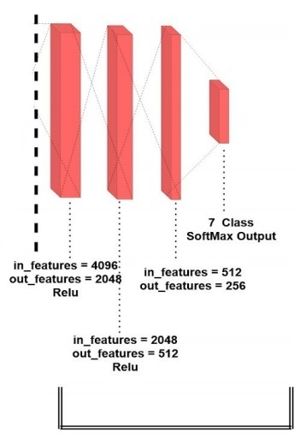

Figure 2: DNN

**3.2 TRANSFER LEARNING**

Transfer learning is the technique to start with and train a pre-trained model for a new related problem domain. However, there are many options that can be used, including feature transfer and fine-tuning (depending on the similarity of the problems at hand), as well as freezing certain layers of the network and retraining others. If there is insufficient training data, an existing model (from a related problem domain) can be used with additional training to support the new problem domain. The networks used in this approach are mentioned below.

# **3.3 DENSENET-121**

# A characteristic trait of this network is that each layer acquires additional inputs from all preceding layers and tags on its own feature-maps to all subsequent layers. Employed pre-trained densenet network consists of 4 dense blocks which in turn comprise of 6, 12, 24 and 16 dense layers respectively. Every adjacent dense block is amalgamated with a transition block. So, in total, three transition blocks were used. Lastly, the dense neural network with 1024 input features and 512 output features in the first layer, was integrated with the pretrained densenet network.

# Subsequently, two additional linear layers with a drop out factor of 0.3 were also added. Ultimately the modified network was followed by the output layer (softmax) with seven (output) classes. An accuracy of 98.72% was observed with a learning rate of 0.0497870684, adam optimizer and cross entropy loss function with the modified Densenet-121 network.

# **3.4 RESNET-50 and WIDE RESNET-101**

# Resnet and Wide Resnet networks consist of BottleNeck blocks. These are similar to BasicBlocks. A BottleNeck block uses a 1x1 convolution to minimize input channels before performing an expensive 3x3 convolution. It then uses another 1x1 convolution to project it back into the original shape. Resnet has four sequential blocks. Each sequential block has a certain number of bottleneck layers. The reason for using bottleneck blocks is to optimally utilize the GPU RAM and not squander it with those expensive 3x3 convolutions. The number of bottleneck blocks in the four sequential blocks are 3, 4, 6 and 3 respectively. Wide Resnet’s architecture is heavily inspired by Resnet’s architecture. It differs in the number of bottleneck blocks in the third sequential block, which are 23 in its case. The number of filters in the convolutional layer have also increased when compared to resnet. Lastly, the novel dense neural network with 2048 input features and 1024 output features in the first layer, was integrated with both of the pretrained Resnet and Wide Resnet networks. Subsequently, two additional linear layers with a drop out factor of 0.3 were also added. Ultimately the modified networks were followed by the output layer (softmax) with seven (output) classes. Again, the Relu activation function was utilised for activating the neurons.

**3.5 VGG-19**

# VGG-19 DCNN was constructed and the model parameters were fine-tuned, as per the model training and test results. VGG network is structured primarily with multiple connected convolutional layers and fully connected layers. The number of convolutional layers and fully connected layers are sixteen and three respectively for the VGG-19 network. The size of the convolutional kernel is 3x3 and the input size is 224x224x3. Sixty-four kernels from the first convolutional layer, were utilized for feature extraction from the input images. Since it is built with an alternating structure of multiple convolutional and non-linear activation layers, it thumps over a single convolution. It can better extract image features, utilise max-pooling for down sampling and modify the linear unit (ReLU) as the activation function. This implies that it has the ability to select the largest value in the image area as the pooled value of that area. The main purpose of implementing the down sampling layer is to better the anti-distortion ability of the network while retaining the main features of the image sample and to reduce the number of parameters. All the layers in the network, except the last five, are freezed during training. After which the updated weights were fed into the new deep neural network which comprises a sequential block having four linear layers. The modified network was activated using the ReLU function and connected to the softmax output layer with seven (output) classes.

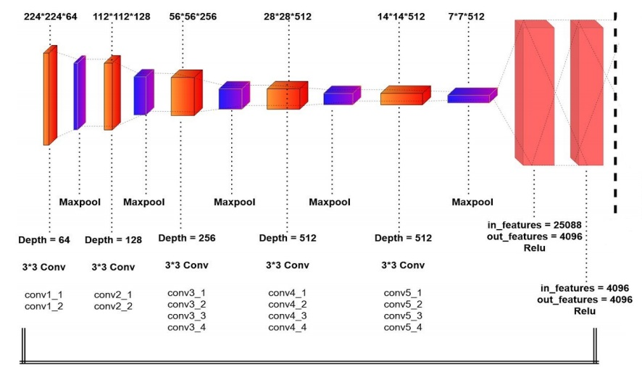

Figure 3: VGG-19

# The final model is the combination of VGG-19 and CNN. An accuracy of 99.04% was recorded with this model

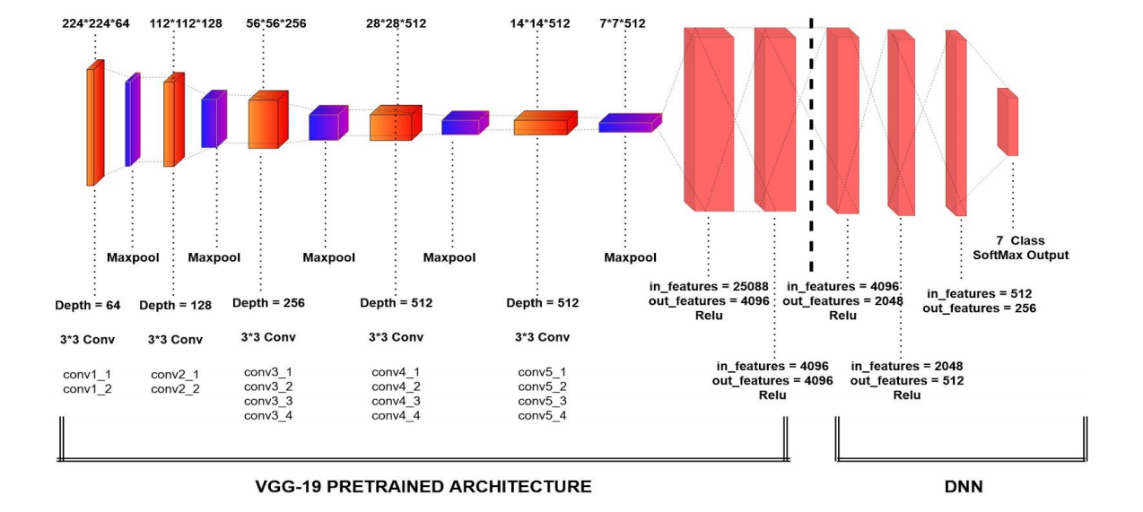

Figure 4: Modified VGG-19

# The classification report table for all the seven types of skin lesions classified by the network

**Table 2: CLASSIFICATION REPORT TABLE FOR MODIFIED VGG-19**

|  |  |  |  |
| --- | --- | --- | --- |
| **Types of skin lesion** | **Precision** | **Recall** | **F1-Score** |
| Melanocytic nevi | 1 | 1 | 1 |
| Melanoma | 0.99 | 1 | 0.99 |
| Benign keratosis | 0.98 | 0.98 | 0.98 |
| Basal cell carcinoma | 1 | 1 | 1 |
| Actinic keratoses | 0.98 | 0.95 | 0.97 |
| Vascular lesions | 1 | 1 | 1 |
| Dermatofibroma | 0.98 | 1 | 0.99 |

# The reason for the higher performance of with deeper networks is that it can learn more complex and non-linear functions of. If enough training data is provided, will allow the network to easily distinguish classes. The reason for extending the pre-training network to a deeper neural network is to maximize the feature extraction potential of the system

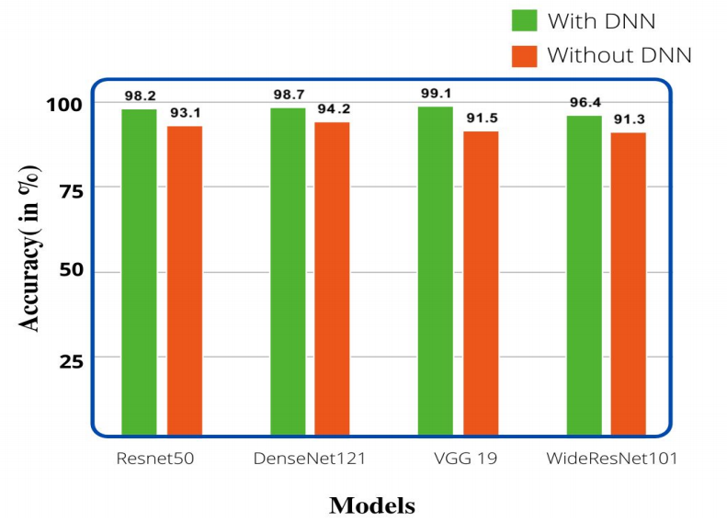

FIGURE 5: Accuracy comparison with and without DNN

# By analyzing the bar graph shown in Figure 5, we can draw the conclusion from that adding an external DNN through can improve any previously trained network. This improves the overall precision and accuracy of the model. When combined with DNN, the performance of the VGG-19 network is very good, reaching, reaching 99.04% accuracy. Meters

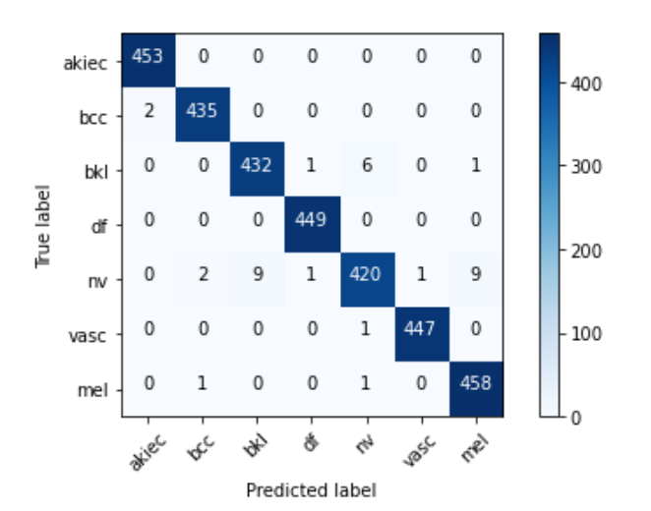

**Figure 6: Confusion Matrix**

**AGE VS LESION**

# From the age vs. lesion plot shown in Figure 7, It can be inferred that among people over 50 and a half years old, there is a significant increase in melanoma cases (the most fatal people), people of all ages have the highest incidence of vascular disease, and basal cells and actinic the highest incidence of keratosis (before cancer) is, which is distributed among people over 40 years old.

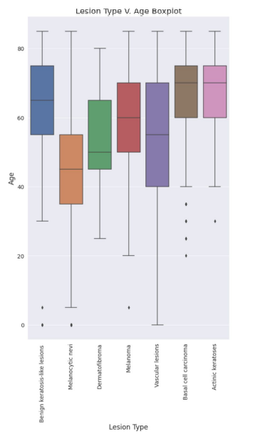

FIGURE 7: Lesion Type Vs. Age Boxplot

**4. CONCLUSION**

The excellent study on the classification of skin lesions paved the way for this comparative study. This study highlights the power of the deep neural network in classifying dermoscopic images of seven major skin lesions observed in humans. It also classifies skin cancer. If used in the real world, it can provide a diagnosis and can save lives. The goal is to achieve a result equal to or better than the current benchmark.

# After the five models were analyzed, the most promising result was obtained using a VGG-19 network with an accuracy of 99.04%. CNN, Width Resnet 101, The accuracy of RESNET50 and DenseNet121 is 81.24%, 96.40%, 98.20% and 98.70%, respectively. The result is a better precision of visual diagnosis using these correction networks, , compared to experts and doctors. The facility of implementation of clearly shows the possibility that these models used in the near future, the skin mirror inspection system and the modern smartphone. The final study the purpose is to build a cutting-edge application for the detection of non-invasive skin cancer using information vision, which is economical compared to global standards and other systems. is already located in the same place.

**5. REFERENCES**

[1] Atharva Jibhakate, Pranav Parnerkar, Sahil Mondal, Vastav Bharambe, Shamla Mantri, "Skin Lesion Classification using Deep Learning and Image Processing", 2021 IEEE​.

[2] Amirreza Mahbod, Gerald Schaefer, Chunliang Wang, Rupert Ecker, Isabella Ellinger, "SKIN LESION CLASSIFICATION USING HYBRID DEEP NEURAL NETWORKS", 2019 IEEE.

[3] Jianpeng Zhang, Yutong Xie, Yong Xia, Chunhua Shen, "Attention Residual Learning for Skin Lesion Classification", 2019 IEEE.

[4] Haroon Rashid, Asjid Tanveer, Hassan Aqeel Khan, "Skin lesion classification using GAN based data augmentation", 2019 IEEE.

[5] Adekamni A. Adegun, Serestina Viriri, "FCN-Based DenseNet Framework for Automated Detection and Classification of Skin Lesions in Dermoscopy Images", 2020 IEEE​

[6] Catarina Barata, Jorge S. Marques "DEEP LEARNING FOR SKIN CANCER DIAGNOSIS WITH HIERARCHICAL ARCHITECTURES" ,2019 IEEE

[7] B Harangi "Skin lesion classification with ensembles of deep convolutional neural networks", 2018 Elsevier

[8] Sertan Kaymak, Parvaneh Esmaili, Ali Serener "Deep Learning for Two-Step Classification of Malignant Pigmented Skin Lesions ", 2018 IEEE.

[9] Shunichi Jinnai, Naoya Yamazaki, Yuichiro Hirano, Yohei Sugawara, Yuichiro Ohe, Ryuji Hamamoto "The Development of a Skin Cancer Classification System for Pigmented Skin Lesions Using Deep Learning", 2020 Biomolecules

[10] Russell C. Hardie, Redha Ali, Manawaduge Supun De Silva, Temesguen Messay Kebede "Skin Lesion Segmentation and Classification using Traditional Classifiers with Hand-Crafted Features", 2018 ISIC

**6. BASE PAPER FIRST PAGE**

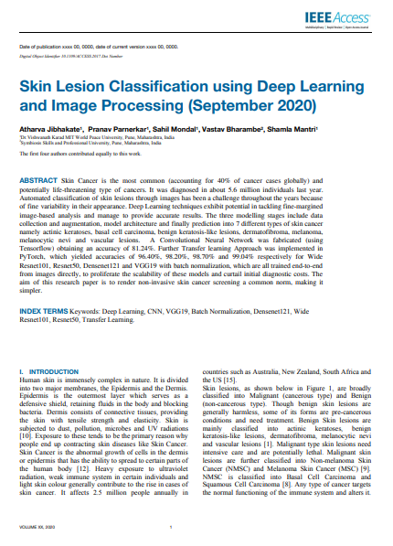

**7. PLAGIARISM CHECK REPORT**

